Analytics Tableau Design & Performance Guide

Purpose
This guide is meant to help provide a cohesive look and feel for our published Tableau reports in Analytics so our audience will have a consistent user experience. The defined standards will also help improve the report development process for analysts and encourage effective dashboard visualizations. The following are recommendations and can be adjusted depending on the user request and other factors.

Contributors
Angela Shi, ashi@cotality.com
Pavithra Vijayakumar, pavijayakumar@cotality.com

Last Revised
Version 3.0 Updated October 29, 2026

Dashboard Best Practices
This section contains guidelines designed to help build effective, user-friendly and performant dashboards. Based on business intelligence design standards and optimization techniques, these practices aim to create a more intuitive experience for the audience and streamlined workflow for the developer.
- Purpose and Structure: A successful dashboard starts with a clear plan.
  - Define a Clear Purpose: Every dashboard must answer a specific set of business questions for a defined audience. Avoid trying to do too much with one dashboard, which leads to a confusing user experience and poor performance.
  - Limit Views to 6 or Fewer: To maintain clarity and workbook efficiency, a dashboard should contain a maximum of 6 views or worksheets. Each view should serve a purpose.
  - Hide Unused Sheets: To keep the workbook clean, hide all worksheets that are used in the dashboard. Any sheet not used should be deleted.

- Usability and Interactivity: The audience must be able to understand and interact with the dashboard intuitively.
  - Provide Clear Instructions: Do not assume users will know how to use your dashboard. Include text or an information icon that provides clear, concise instructions on how to use filters, actions and any drill-down functionality
  - Ensure all Actions and Filters Work: Test every filter and dashboard action to confirm they work as expected and filter the correct elements.
  - Write Effective Tooltips: Tooltips should provide value, not just repeat what is already visible. Use them to offer additional context, define a metric, or show more granular data.

- Naming and Labeling:
  - Use Business-Friendly Names: All titles, labels and metric names should be written in plain language that a business user can understand. Avoid using raw data field names from the source database or Tableau generated labels.
  - Spelling: Workbook should not have spelling errors.

Technical Name | Business Friendly Name
sales_region_CY | Sales Region (Current Year)
SUM(Profit) | Total Profit

- Performance: The user’s experience is diminished if a dashboard is too slow to load or interact with.
  - Target Load Time: Dashboard ideally should load in under 8 seconds.
  - Use Workbook Optimizer: Before submitting for review, run Tableau’s Workbook Optimizer and address all items marked as Take Action and Needs Review
  - Optimize Filters:
    - For multi-select filters, enable the Apply button to reduce multiple data refreshes.
    - Avoid using filters that contain long lists of unique values such as hundreds of business names. If necessary, convert filter to a wildcard match or search box.
  - Avoid Custom SQL: Whenever possible, use Tableau’s native data relationships or joins instead of custom SQL. Custom SQL will significantly reduce workbook performance, especially in live connections.

Layout
1) Template: All dashboards must be built using our official Analytics template to ensure consistency in branding, layout and metadata. This pre-builds required layout elements. Download the template file based on whether your dashboard is for:
- General Analytics request
- amp’d Specific request
Sample layout with header:
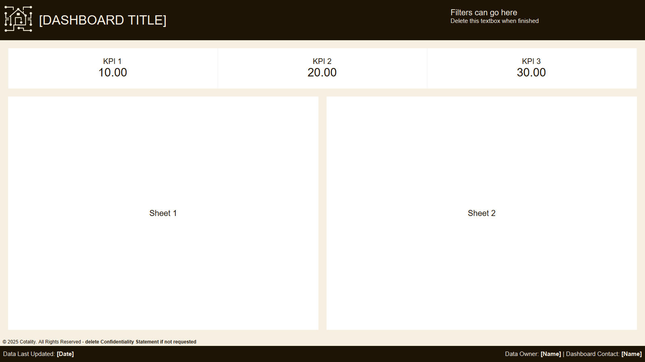
Sample layout with sidebar:
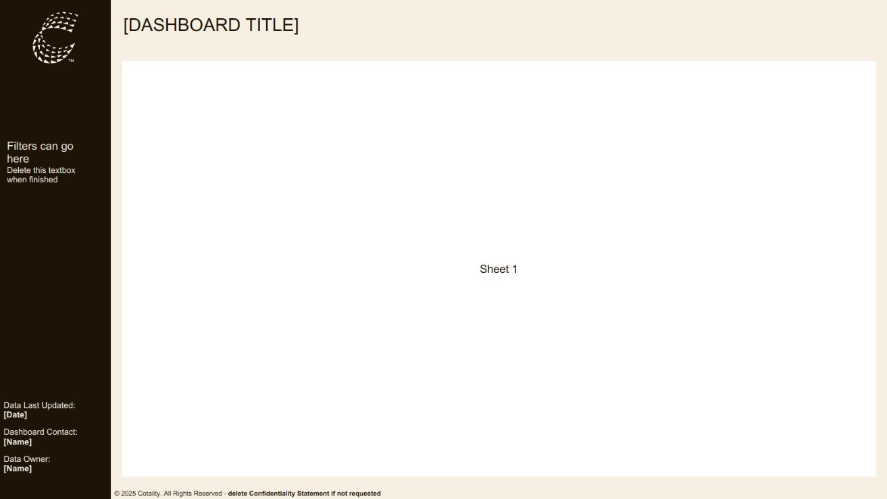
2) Size:
- Dimensions: 1600x900 (PowerPoint size) for minimal scrolling. Try to avoid scrollbars within views.
- Use fixed size for optimal performance.
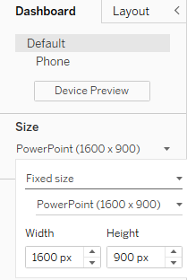

3) Required Dashboard Elements:
Element | Requirement | Location
Logo | amp’d logo for amp’d specific dashboards, Cotality logo for non-amp’d dashboards | Upper-left corner
Dashboard Title | Clear and descriptive. Use the size specified in Typography | Top of dashboard
Metadata | All fields filled out including data update date, dashboard contact and data owner (if different from contact) | Footer or sidebar

An optional element of a dashboard is included in the template footer and can be deleted if not required. Use upon stakeholder request or specific use cases.
- Confidentiality statement or,
- Trademark statement

4) Structure
- Use Tiled Containers by Default: Primary dashboard components such as charts, KPIs and filters should be placed in tiled containers where possible. This ensures the layout renders predictably when published
- Padding: Consistent spacing (padding) helps prevent a cluttered look. Outer padding adds space outside of the worksheet border while inner padding adds space inside the worksheet border. The Analytics template uses 20px for outer padding of worksheets (a minimum of 10px is required) and 10-15px for inner padding, which can be adjusted as needed.
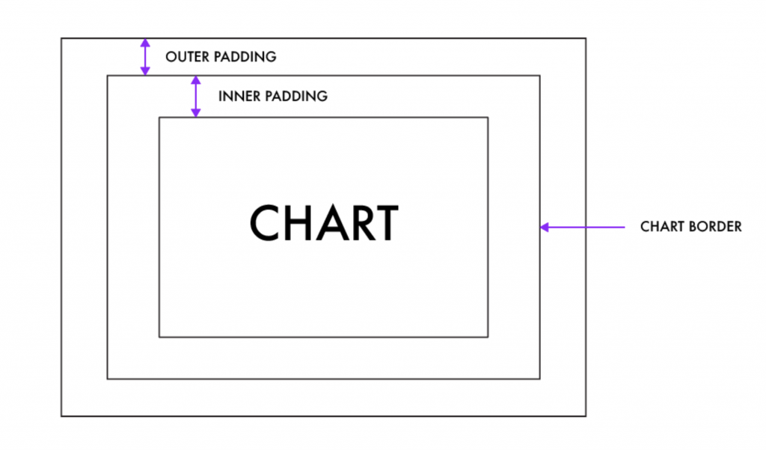
- Organize by Importance: Order from top to bottom, left to right. Start with the most important, aggregated metrics at the top like KPIs. Less important and more granular views such as data tables and detailed charts can be placed at the bottom.
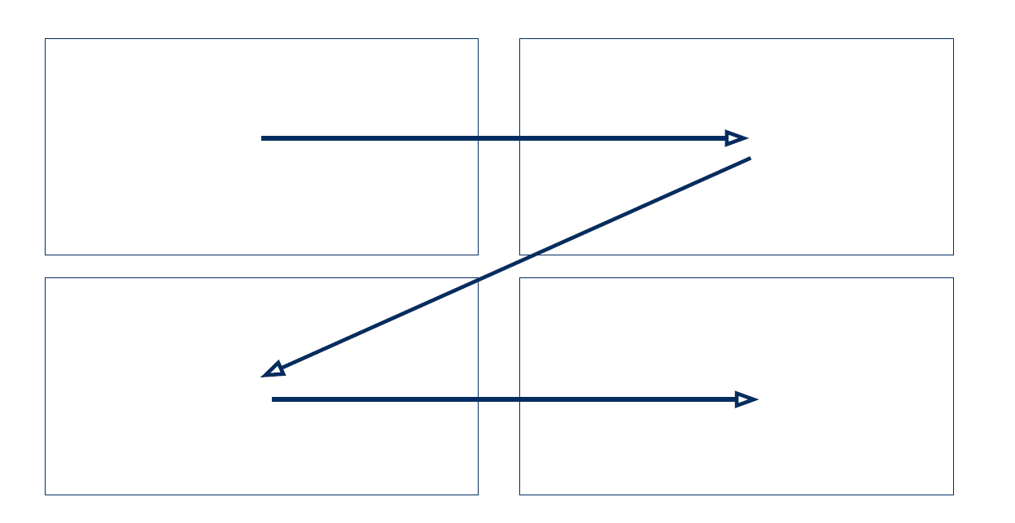
Colors
Currently dashboards must use colors from Cotality’s new branding. This consists of neutrals, a primary palette and extended palette.
To use Cotality’s brand colors in your workbook, a custom color palette needs to be created first. Follow these steps to create a custom color palette and easily access brand colors when building your views. The Analytics template instructions will include hex codes of each palette for your convenience.

Neutrals:
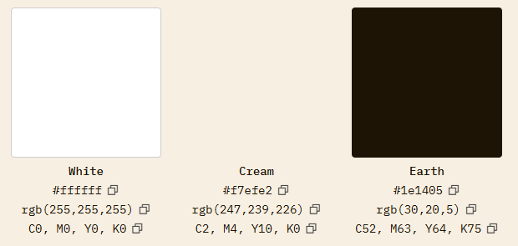

Primary Palette:
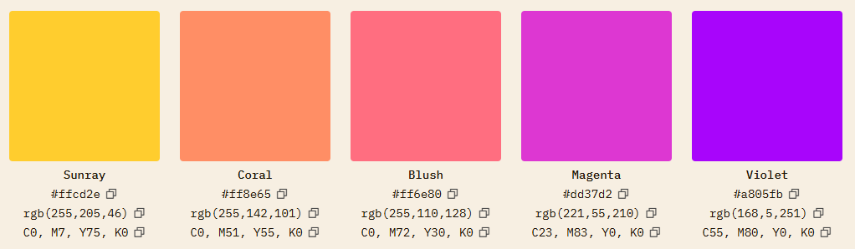

1) Color Application:
When building your dashboard, use 1-2 dominant colors from Cotality’s primary palette to highlight important metrics, and neutral shades (grays) for other mark values. The extended palette can also be used to supplement your views as needed. Keep colors consistent throughout dashboards in the same workbook.

2) Color Assignments:
The following color standards, which have been incorporated into the Analytics template, apply to all dashboards:
- Dashboard header or sidebar color: Earth
- Dashboard background color: Cream
- Chart background color: White
- Overall workbook text color: Earth
- Text color for dashboard elements on an Earth background: Cream
- Metadata text color: Cream

3) Accessibility First:
- Avoid Red/Green: Be mindful of accessibility for users with color blindness
- Check Contrast: Ensure your text is readable against its background
- Grayscale Test: Design your dashboard in grayscale first. If the data is understandable without color, your design is effective.

4) Predesigned Palettes:
For specific use cases, predesigned palettes have been created your convenience and can be found in the template instructions page above. These predesigned palettes have limited color options so please feel free to use a different color from Cotality’s palette if your dashboard is using a different dominant color.
- Cotality Sequential: Use to assign colors to a dimension using variations of a single color, with many dimension members. Current option is Coral.
- Cotality Diverging: Use to assign colors to a measure that diverges. Current options are Teal and Grey.
Typography
- Arial: Standard font for all text in the workbook. It’s a web-safe font so it displays correctly on other users’ devices
- Arial Black: Used for worksheet titles.
- How to apply: Go to Format > Workbook. Set All fonts to Arial then set Worksheet Titles to Arial Black. The template workbook is already formatted.
Limit the number of font size categories per workbook. Use the same font size for each category of text. The following recommended font categories and sizes are:
Text | Size
Dashboard Title | 24-28
Subtitle/Chart Title | 15-16
Chart Header | 11-12
Labels/Other Text | 10-11

Be thoughtful about using bolded text and all capitals. These can be used in cases such as emphasizing main titles and KPIs.
Numbers
- Number Precision: Determine how many decimal places is appropriate for the data being displayed. Too many decimal places can clutter your view and make the numbers difficult to read.
- Units and Abbreviations: Show correct unit symbol (%, $) and use abbreviations where appropriate (k, M).
- KPIs: Use larger font sizes to quickly grab the user’s attention and contrast with surrounding text or numbers.
Logo
- For amp’d dashboards, use the amp’d logo without text when using the template version that contains the header and footer. Use the amp’d logo with text when using the template version that contains the sidebar.
- For general Analytics dashboards, use the Cotality logomark.
- Access logo options on SharePoint.
Icons
- Use Cotality’s new iconography. The instructions and settings for downloading from Google’s Material Design are located here. An Optical Size of 48px is recommended for a crisper look.
- Backgrounds: Earth icons should be used on light backgrounds and Cream icons should be used on dark backgrounds:
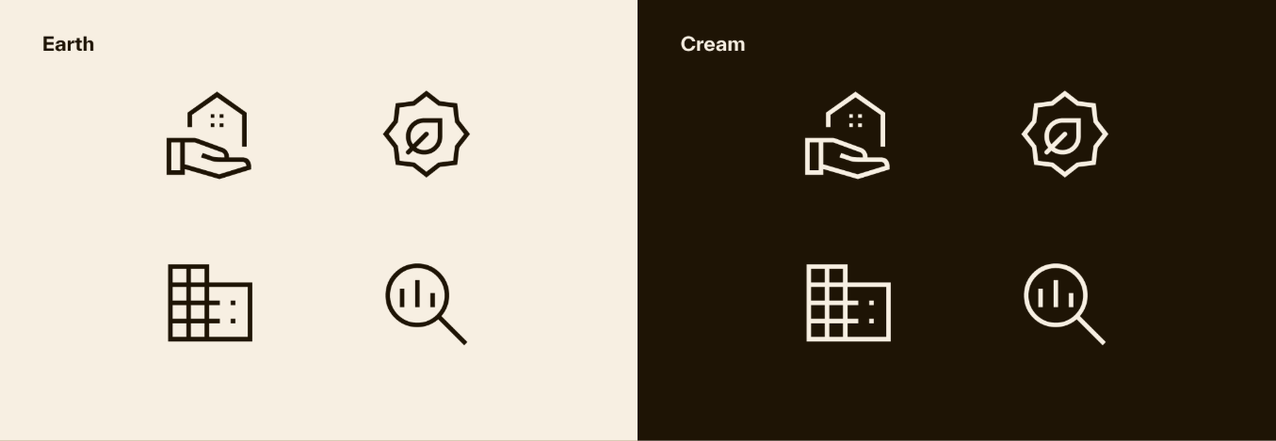

- Buttons: If icons such as Information and Export buttons are requested, place them in the upper right corner of the template, with a width of 50px:
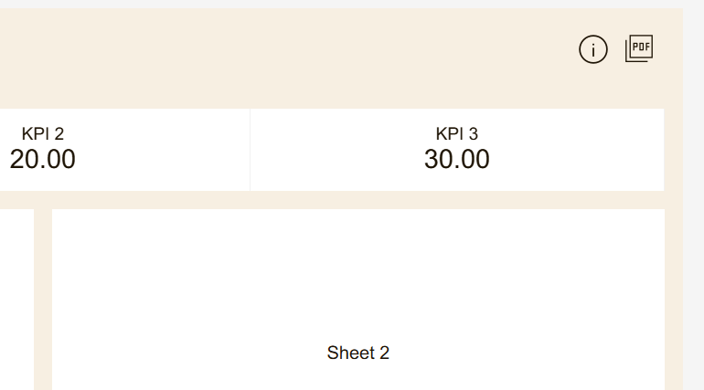

Chart Best Practices
- Reduce Clutter: Remove unnecessary chart gridlines and borders.
- Number of Marks: Too many marks may cause information overload and will negatively impact workbook performance.
- Chart Labels: Label marks or show the axes but not both, for a cleaner visualization.
- Improve Readability: Avoid vertically aligned labels and overlapping text where possible.
- Tooltips: Utilize to provide helpful information about the data and any needed context.

Recommended Chart Types:
Change over Time: Line Chart, Slope Chart, Highlight Table
Correlation: Scatter Plot, Highlight Table
Magnitude: Bar Chart, Bubble Chart, Line Chart
Deviation: Bullet Chart, Bar Chart, Combination Chart
Distribution: Histogram, Population Pyramid, Pareto Chart, Box Plot
Ranking: Bar Chart, Bump Chart
Part-to-Whole: Pie chart, Area Chart, Stacked Bar Chart, Treemap
Spatial: Filled Map, Heat Map, Symbol Map, Hex Map
Flow: Sankey, Waterfall

Common Chart tips:
Line Chart: Having too many lines and colors/categories will cause confusion. It is more effective to highlight one category to easily compare it to the others.
Pie Chart: Use if you have no more than 3-4 categories and the wedge sizes differ significantly.
Bar Chart: Have clearly labeled axes or marks. Do not display too many bars, colors, and subcategories.
Scatter Plot: Clearly label marks and do not have too many marks in a view. Don’t use too many different shapes and colors.
Treemap: Use to visualize a few distinct categories with a distinct hierarchy.
Text Table: Do not use if you are trying to show relationships in your data or there are too many marks and categories.
Highlight Table: Don’t use multiple colors in one table or have similar colors for different measures.

